**①安装VMware-workstation-full-14.0.0.24051并新建虚拟机ubuntu-16.04.3-desktop-amd64**

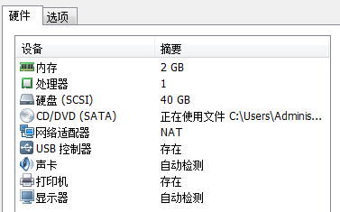

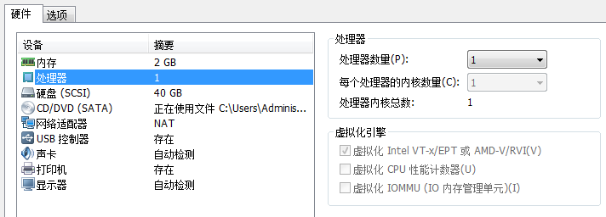

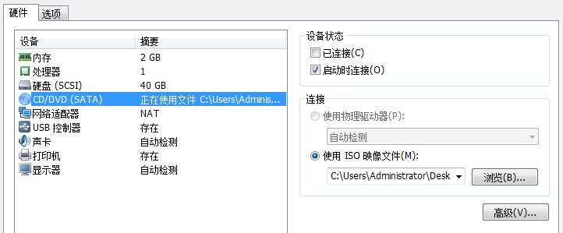

**②安装VMware tools**

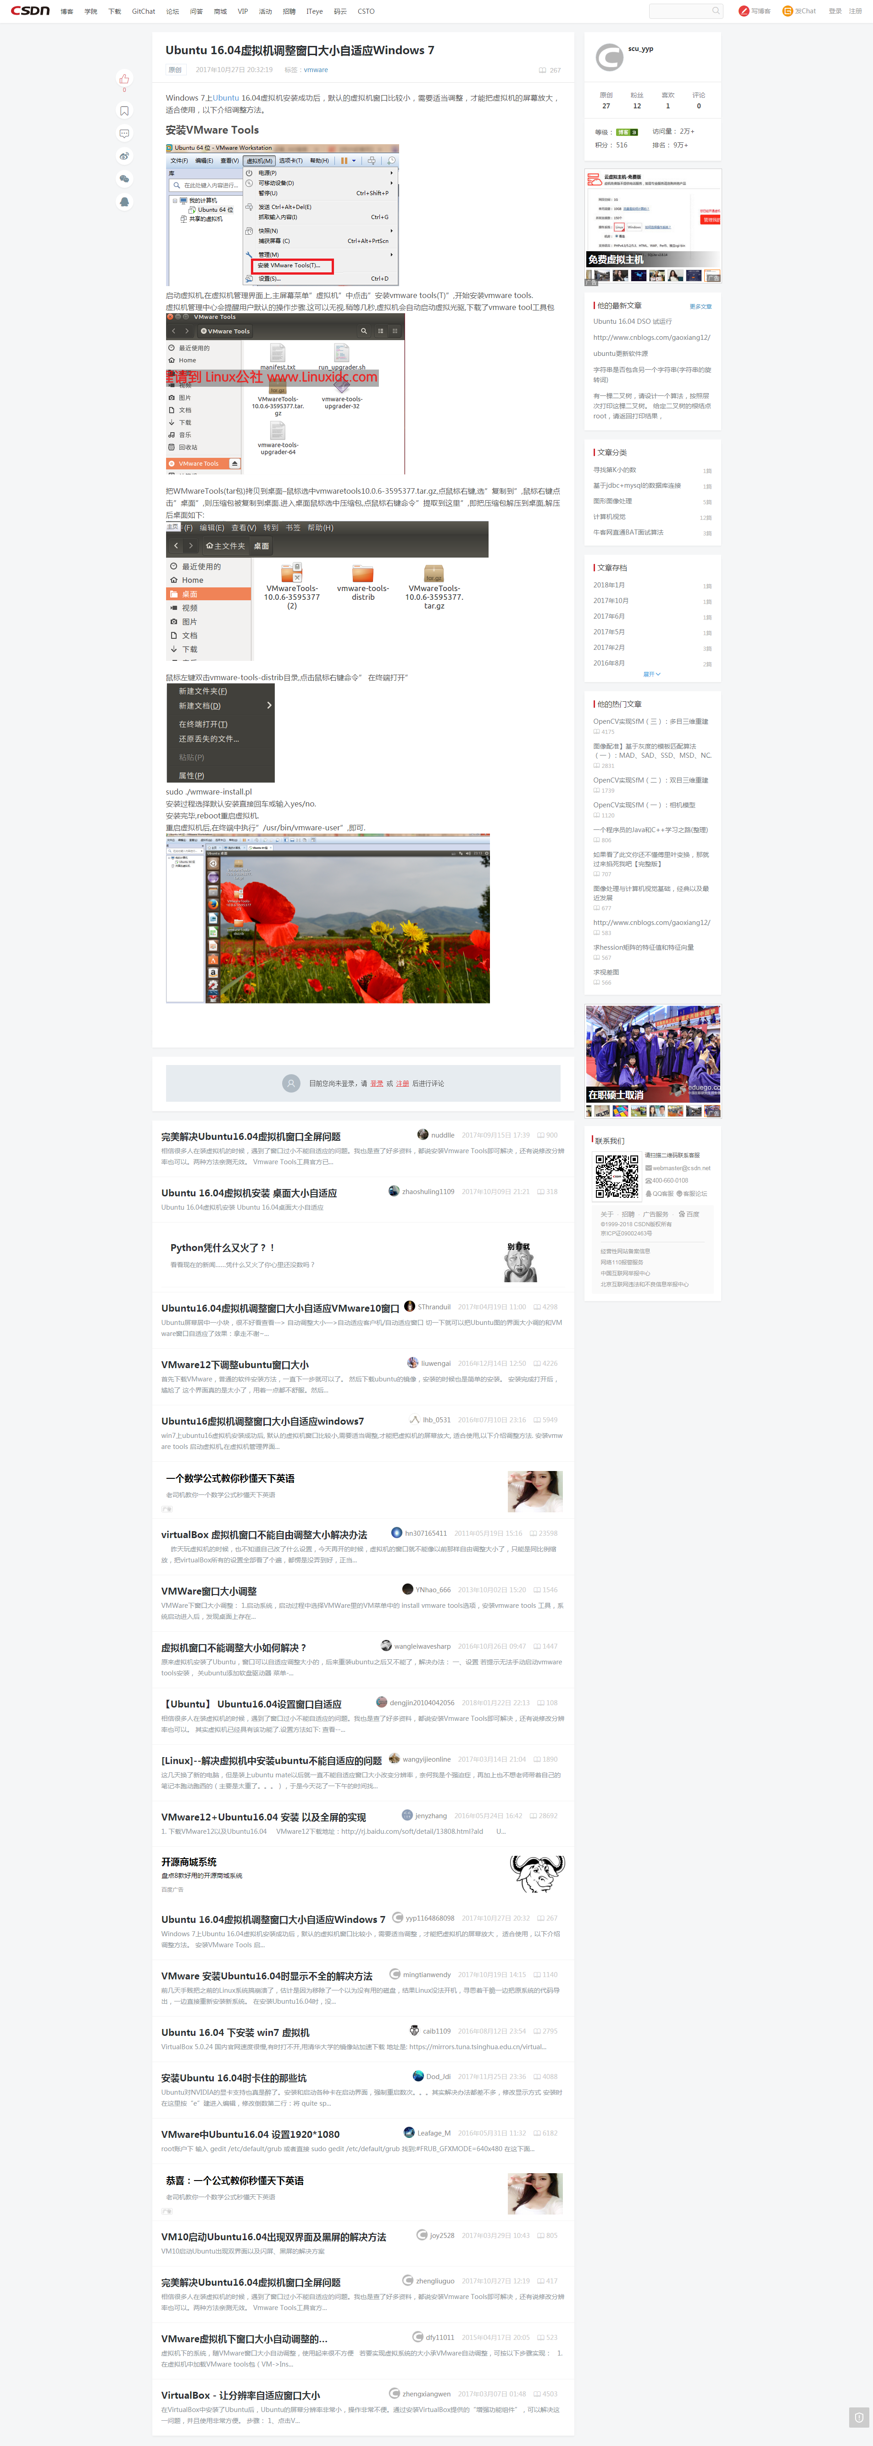





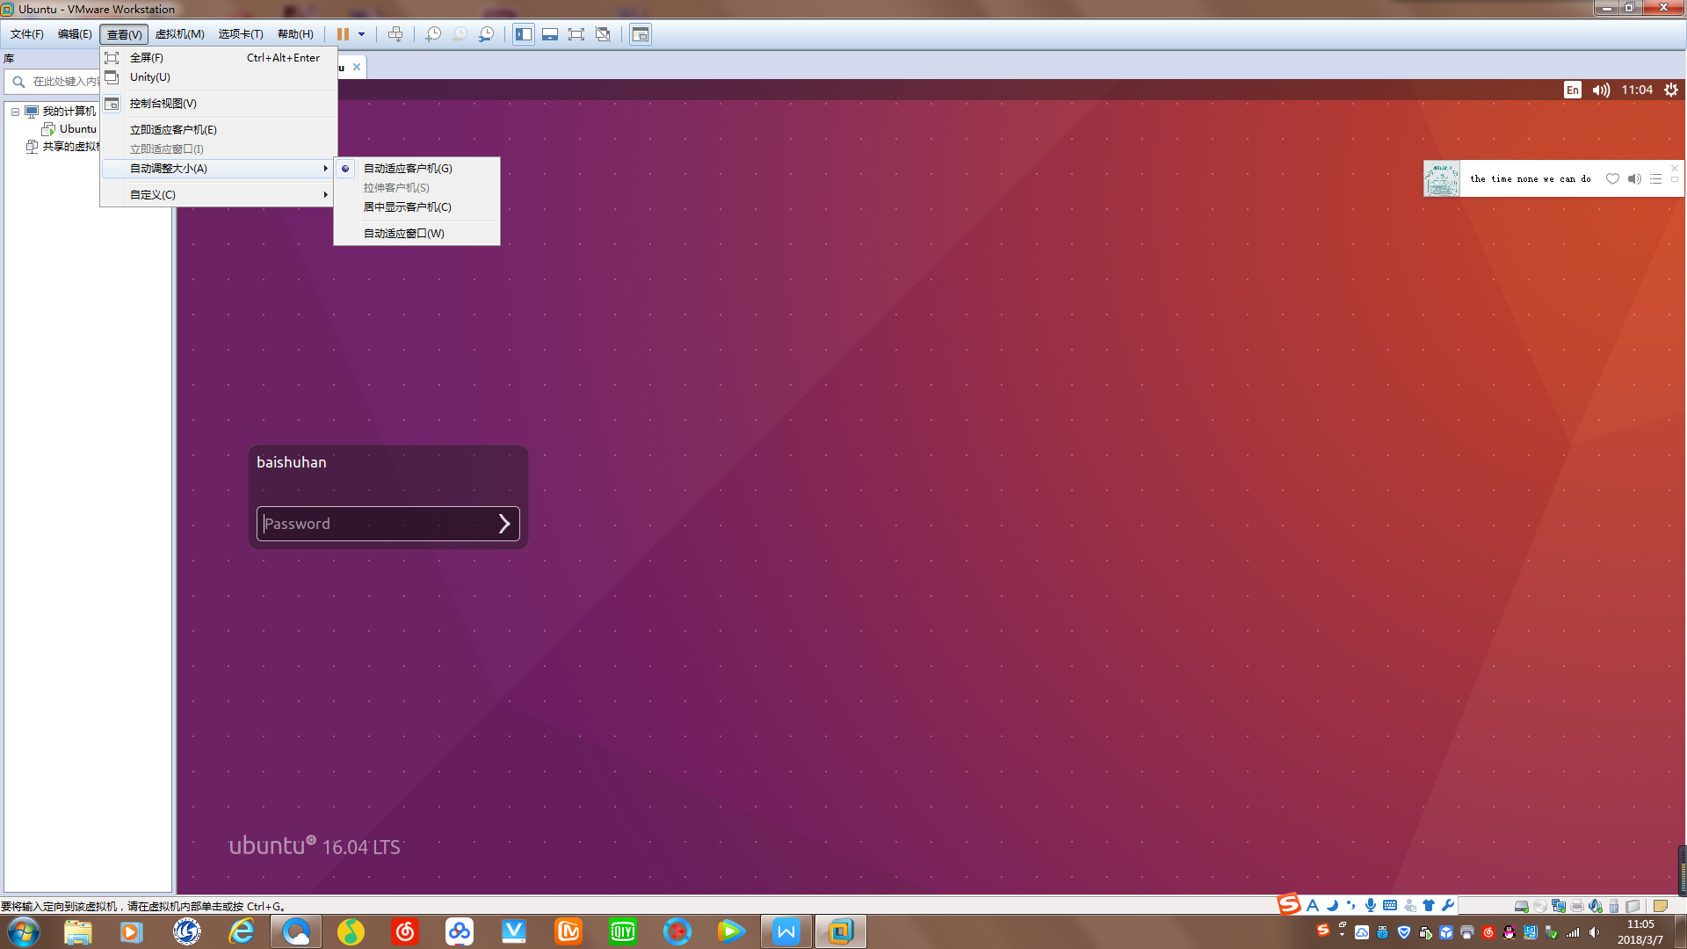

**③安装中文输入法**

1.安装语言包  
System Settings–>Language Support–>Install/Remove Languages  
选中chinese，点击Apply应用即可，等待下载安装完成。  
2.安装ibus框架  
sudo apt-get install ibus ibus-clutter ibus-gtk ibus-gtk3 ibus-qt4  
3.启动ibus框架：im-config -s ibus  
若用im-switch来切换框架，则提示im-switch: command not found，现该命令已改成im-config  
4.安装拼音引擎  
若是IBus拼音：sudo apt-get install ibus-pinyin  
5.设置ibus框架：sudo ibus-setup

若如下图无Chinese选项，则需要重启虚拟机

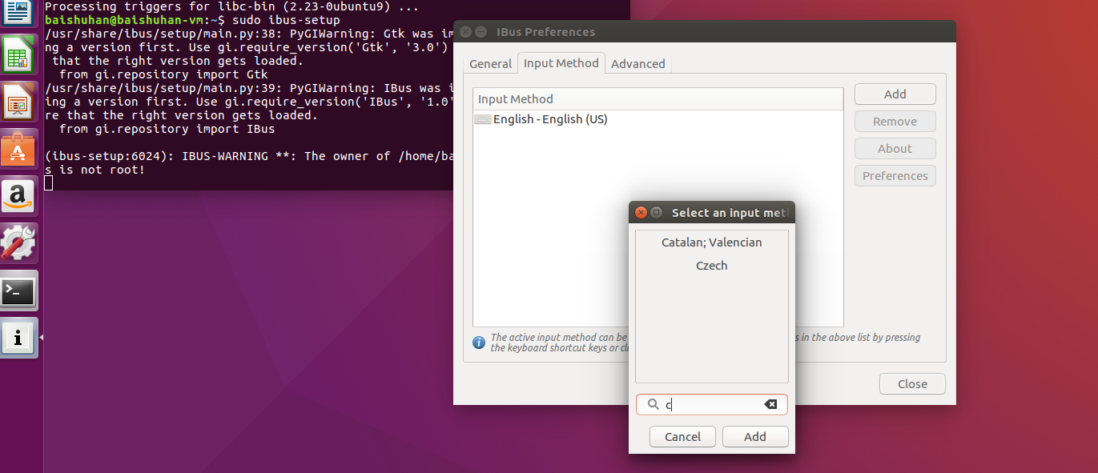

选中input method，Add刚才安装的中文拼音。

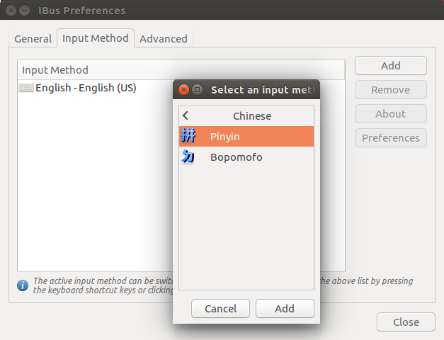

6.添加输入法

设置中选到Text Entry，点击左下角的加号，把自己要用的输入法添加进来，方便以后切换。

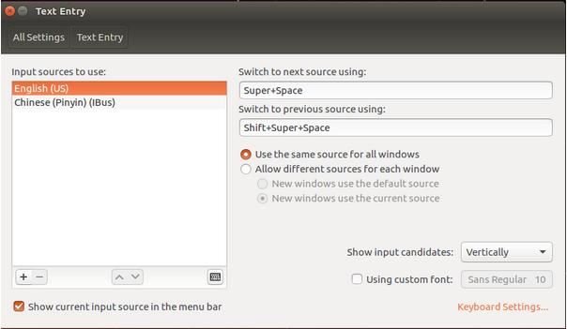

其中切换快捷键 linux中super即windows中win键



linux中space即windows中空格键

若不能上网则：

控制面板→系统和安全→管理工具→服务→下拉至VMware等选项并将其启动

**④安装qemu**

1.apt-get安装：sudo apt-get install qemu

安装完成后，在命令行终端上输入qemu，然后按多次Tab键，就会列出qemu当前所支持的cpu：

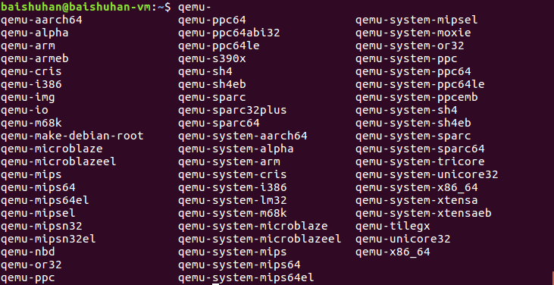

2.源码安装

1）网站https://github.com/OpenChannelSSD中下载qemu源码：qemu-nvme

2）将.zip压缩文件复制至Desktop并解压

3）进入源码目录：cd ~/Desktop/qemu-nvme-master

并配置源码：./configure --enable-linux-aio --target-list=x86_64-softmmu --enable-kvm

错误：Disabling libtool due to broken toolchain support

ERROR: zlib check failed

Make sure to have the zlib libs and headers installed.

解决：sudo apt-get install zlib1g zlib1g-dev

错误：Disabling libtool due to broken toolchain support

ERROR: glib-2.12 gthread-2.0 is required to compile QEMU

解决：sudo apt-get install libglib2.0-dev

ERROR: pixman >= 0.21.8 not present. Your options:

(1) Preferred: Install the pixman devel package (any recent

distro should have packages as Xorg needs pixman too).

(2) Fetch the pixman submodule, using:

git submodule update --init pixman

解决：sudo apt-get install libpixman-1-dev

ERROR: User requested feature linux AIO

configure was not able to find it.

Install libaio devel

解决：sudo apt-get install libaio-dev

4）编译：make -j8

5）安装：make install

错误：install -d -m 0755 "/usr/local/share/qemu"

install: cannot change permissions of ‘/usr/local/share/qemu’: No such file or directory

Makefile:378: recipe for target 'install-datadir' failed

make: *** [install-datadir] Error 1

解决：sudo make install

**⑤在qemu上安装ubuntu**

1.Create an empty file to hold your NVMe device

dd if=/dev/zero of=blknvme bs=1M count=1024

2.Download Ubuntu and install it in QEMU. Start by creating a disk image and booting Ubuntu from an ISO.

qemu-img create ubuntu.img 30G

qemu-system-x86_64 -hda ./ubuntu.img -boot d \

-cdrom ~/Desktop/ubuntu-16.04.3-desktop-amd64.iso --enable-kvm -m 2G -smp 12

错误：VNC server running on `127.0.0.1:5900'

解决：sudo apt-get install libsdl1.2-dev 并重新执行步骤④中2.源码安装的3/4/5步 再重复

3.After installation, restart the VM with the following parameters

关闭qemu上ubuntu，于外层ubuntu的终端上输入以下指令以重启qemu上ubuntu

qemu-system-x86_64 -hda ./ubuntu.img --enable-kvm -m 2G -smp 12 \

-drive file=./blknvme,if=none,id=mynvme \

-device nvme,drive=mynvme,serial=deadbeef,namespaces=1,lver=1,lmetasize=16,ll2pmode=0,nlbaf=5,lba_index=3,mdts=10,\

lnum_lun=8,lnum_pln=1,lsec_size=4096,lsecs_per_pg=4,lpgs_per_blk=512,ldebug=0,lstrict=1 \

-net user,hostfwd=tcp::7777-:22 -net nic

4.Reboot the vm. Ensure that it is running the kernel that you compiled with uname -a

此时查询到内核版本是4.10 未达到能够安装pblk所需要的4.14 则后续仍需要编译内核

**⑥Compile and Install NVMe CLI, liblightnvm and pblk-tools（在qemu上Ubuntu上安装）**

1.Install Nvme CLI

1）于 <https://github.com/linux-nvme/nvme-cli>下载安装包并解压并移至Desktop

2）cd ~/Desktop/nvme-cli-master

3）make

4）sudo make install

2.Install liblightnvm

1）于 https://github.com/OpenChannelSSD/liblightnvm下载安装包并解压并移至Desktop

2）cd ~/Desktop/liblightnvm-master

3）make dev

错误：/bin/sh:1:cmake:not found

** Please install ‘cmake’ **

Makefile:19:recipe for target ‘cmake_check’ failed

make:*** [cmake_check] Error 1

解决：安装cmake

1. cd退出当前子目录
2. 于 https://cmake.org/download/下载安装包cmake-3.10.2.tar.gz并解压并移至

Desktop

3）cd ~/Desktop/cmake-3.10.2

4）./bootstrap

5）make

6）sudo make install

7）cd退出当前子目录

8）cmake --version验证版本

错误：CMake Error at tests/CMakeLists.txt:9 (message):

Please install libcunit (e.g. ‘libcunit1-dev’ on Ubuntu 16.04)

解决：sudo apt-get install libcunit1-dev

4）sudo make install

3.Install pblk-tools（内核4.14+）（编译内核）

1）于https://github.com/OpenChannelSSD/linux/tree/for-4.15/pblk下载安装包并解压并移至Desktop

2）cd ~/Desktop/linux-for-4.15-pblk

3）make menuconfig

错误：

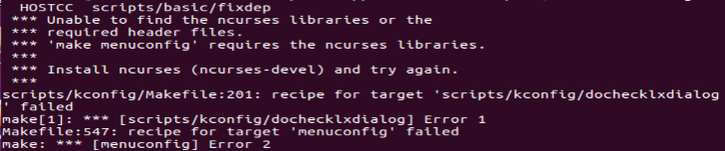

解决：sudo apt-get install ncurses-dev

完成下图对应选项的设置并保存

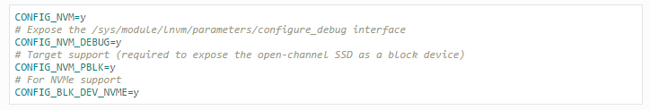

于QEMU中：

①

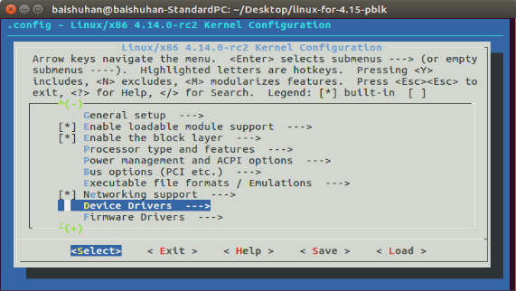

②

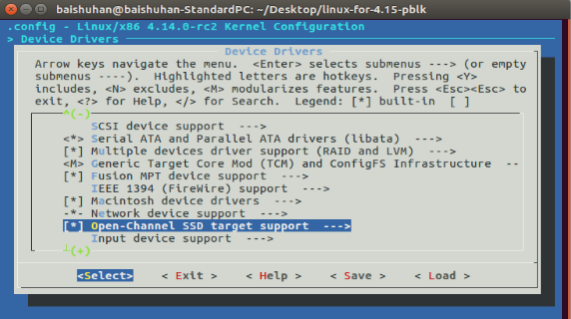

③全部改为Y并保存

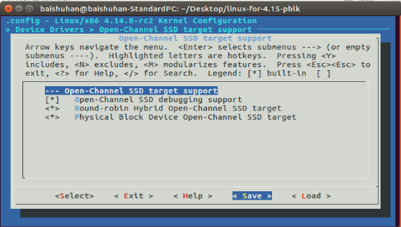

④

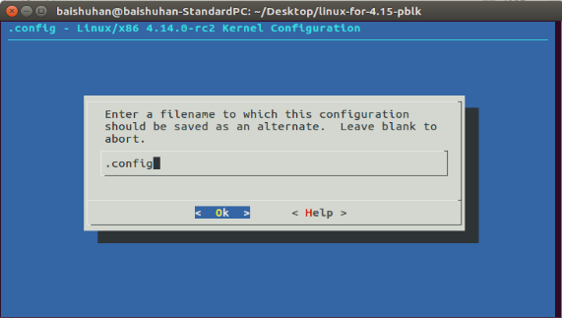

⑤完成

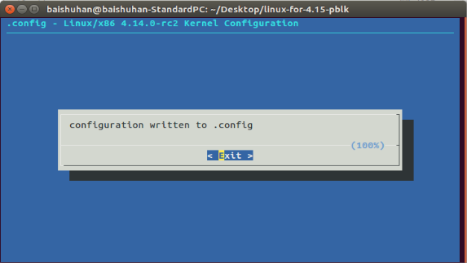

4）sudo make -j4 (建议采用多线程编译加快编译速度←命令中-j4表示4线程编译)

错误：

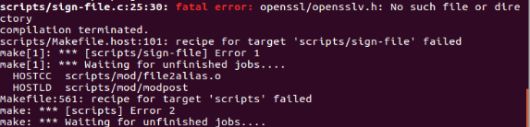

解决：sudo apt-get install libssl-dev

1. sudo make modules_install
2. sudo make install
3. 重启QEMU环境：sudo shutdown -r 0
4. 查看内核版本：uname -a

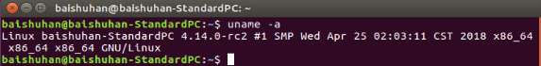

**⑦Try Command line（在qemu上Ubuntu上验证）**

1.LightNVM can be interfaced through the nvme cli tool(nvme-cli).It allows you to create,delete, and manage LightNVM targets and devices.After nvme cli has been installed,its commands can be listed with:nvme lnvm --help

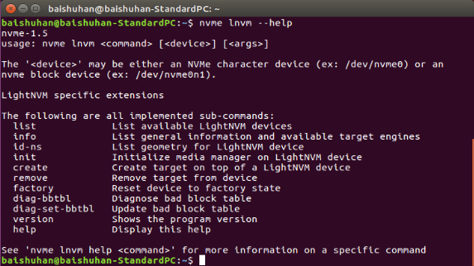

2.To list devices and targets supported devices register with LightNVM upon initialization.

1)To list registered devices:nvme lnvm list

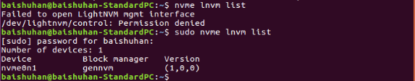

2)To list available targets and their version:nvme lnvm info

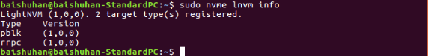

3)CLI:Hello Open-Channel SSD

This “hello-world” example prints out device information of an Open-Channel SSD.Most of the C API is wrapped in a suite of command-line interface (CLI) tools. The “hello-world” example can available from the [nvm_dev](http://lightnvm.io/liblightnvm/cli/nvm_dev.html" \l "sec-cli-nvm-dev) command:nvm_dev info /dev/nvme0n1

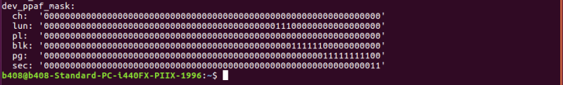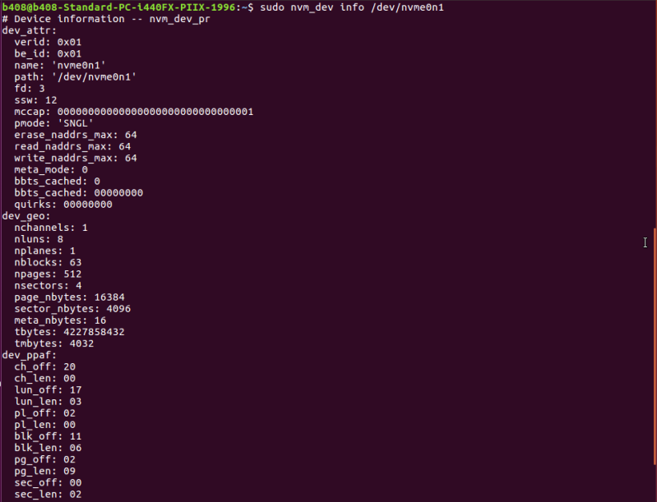

4)A device must first have a media registered when it is first uesd:nvme lnvm init -d nvme0n1

5)To add a target on top of a device registered with the gennvm media manager:

nvme lnvm create -**d** $DEVICE -**n** $TARGET_NAME -t $TARGET_TYPE -b $LUN_BEGIN -**e** $LUN_END

※noted:

1.$DEVICE: Backend device. lnvm devices to list available devices.

2.$TARGET_NAME: Name of the target to be exposed -> /dev/$TARGET_NAME

3.$TARGET_TYPE: Target type. Targets need to be compiled individually before they can be instantiated at run-time. For now, rrpc and pblk are the available implementations.

4.$LUN_BEGIN: Lower bound of the LUN range allocated to the target.

5.$LUN_END: Higher bound of the LUN range allocated to the target.

After successfully registering the target. You may issue reads and writes to /dev/$TARGET_NAME.

For example, to allocate LUNs 0 to 7 to a pblk instance using the NVMe device nvme0n1:

(由上图设备信息中dev_geo可知LUN数为8)

nvme lnvm create -**d** nvme0n1 -**n** mydevice -t pblk -b 0 -**e** 7



A target instance can be removed again by:nvme lnvm remove -**n** targetname

6)Physical Addressing:Most of the library takes one or more physical addresses as parameter.

1.Generic format

The physical addresses are represented in generic format by the data-structure struct nvm_addr. One can construct an address by specifying the relative location within the device geometry down to the granularity of a sector.

Construct an address for sector 3 within page 200 in block 32 on plane 0 of LUN 7 in channel 0:

nvm_addr from_geo /dev/nvme0n1 0 7 0 32 200 3



※noted:Addresses are zero-indexed, so channel 0 is the first channel.

2.Device format

As the output from the device information shows, then there is a notion of a device format. The library user need not be concerned with the device format as the translation to device format is handled by the library for every part of the interface with the exception of the low-level command-interface nvm_cmd.

However, if one needs an address on device format for nvm_cmd or another tool such as nvme-cli, then the generic-format can be converted to device format using:

nvm_addr gen2dev /dev/nvme0n1 0x0007000300c80020



7)Vectorized IO to NAND media

With the basics of obtaining device information and constructing addresses in place one can dive into the task of constructing commands for doing vectorized IO.

As the section on background information describes, then there are handful of constraints to handle for IOs to NAND media to succeed.

1.Erase before write

The first constraint to handle is that a block must be erased before it can be written. With the addresses we can now construct a single command with two addresses and send of the erase:

NVM_CLI_PMODE**=**"0" nvm_addr erase /dev/nvme0n1 0x0000000000000020



If an erase fails as above then it is because a block is bad. The bad-block-table interface (nvm_bbt) is provided to communicate and update media state. Introduction to the bad-block-table is given in a later section.

2.Write

The two primary constraints for issuing writes are that they must be at the granularity of a full flash page and contiguous within a block.

※noted:C API for performing write using vectorized IO with addressing at sector-level is done using nvm_addr_write, note that the payload must be aligned to sector size, the helper function nvm_buf_alloc is provided for convenience.

For the geometry of device, a full flash page is four sectors of each 4096 bytes, a command satisfying the minimum-write constraint thus contains four addresses with a payload of 16384 bytes of data. The command can constructed via the CLI as:

nvm_addr write /dev/nvme0n1 0x0000000000000020 0x0000000100000020 0x0000000200000020 0x0000000300000020

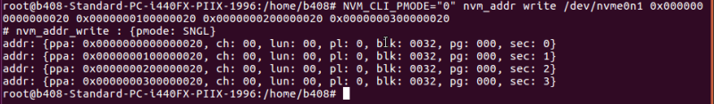

This introduces an additional constraint that writes must be performed to the block accross all planes. One can choose to disable the plane-mode, which is done by setting environment var NVM_CLI_PMODE="0" or by constructing a command satisfying the plane-mode constraint.

3.Read

We can read a single sector:nvm_addr read /dev/nvme0n1 0x0000000000000020



The data read from device can be written to a file system using the -o FILE option,and the payload is then available by inspection, e.g. with hexdump:

